**Hanging Man Candlestick Pattern:**

The body is small enough and the wick or the shadow will be almost twice the body. There is a possibility you may find a very small Wick at the top of the body but there should be very long wick on the bottom.

**If we get a red coloured candle in an uptrend then it has a lot of importance for us.**

**In a hanging man pattern,The close of this candle should be below the close of this candle**

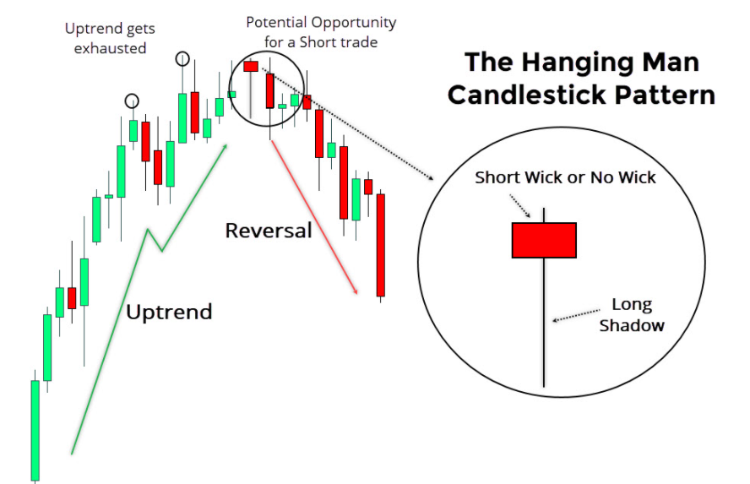

**Hammer Pattern:**

If we get this candle **in** **a downtrend then this is called Hammer pattern** the candle is same

It means we should get a real body at the top and the shadow should be at least twice the real body

In downtrend

It is called a hammer candle because it hammers out the bottom.

**The colour of the body is not much important but if we get a green coloured candle in a downtrend then it is more important one**. **Now in a hammer pattern the next candles close should be above the close of this candle**

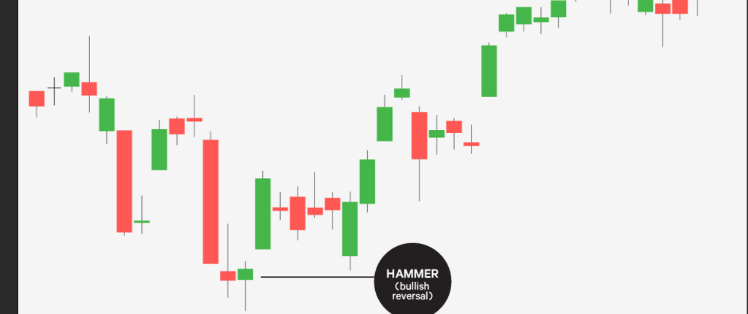

**Shooting Star Pattern:**

That is **a very strong candle reversal candle**. And this candle is similar to the previous two candles

**But in this candle the real body will be at bottom and the shadow will be in upside**. The upper shadow should be at least two times the length of this real body.

**This candle if found in an uptrend and near the resistance level then we can expect a trend reversal from uptrend or downtrend**

**Obviously, the colour of candle is not significant but the next candle close should be below the close**

**of this candle and if we have a green candle before the shooting star candle then it has a lot of significance.**

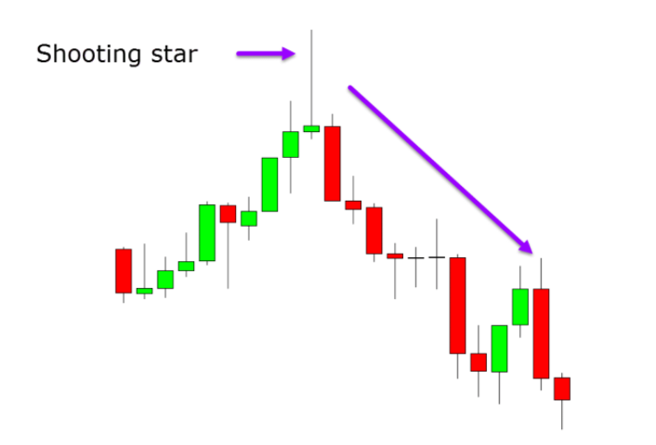

**Doji Candle:**

**Doji is a candle with the same open and closed price**. It is also a significant reversal candle if found **near support and resistance level.**

Now two important variations of doji are **gravestone doji** and **Dragonfly doji**.

**Dragonfly doji:**

It is a candlestick in which open high and close are same with a **long lower** shadow.

This is a bullish reversal candle and gives a signal like a hammer candle.

**FROM DOWNTREND TO UP TREND**

**Gravestone doji**:

It is a candle in which open high and close are same with the **long upper** shadow.

This candle is similar to the shooting star candle and signals about the reversal from

**an uptrend toward downtrend.**

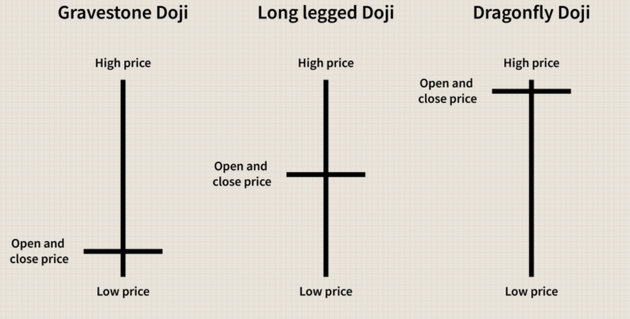

**Marubozu Candle:**

*First,*the single candle involved in the signal should have a long real body. *Second,*there must not be an upper or a lower wick (a.k.a., a shadow).

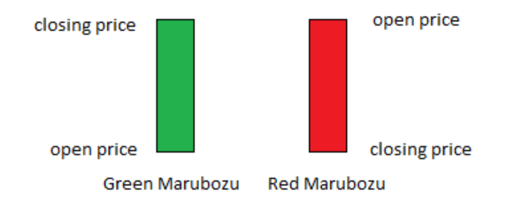

**Engulfing pattern:**

Engulfing patterns provide an approach for traders to enter the market in anticipation of a possible trend reversal.

An engulfing pattern is a **reversal candlestick pattern** that can be bearish or bullish depending upon whether it appears at the end of an uptrend or downtrend.

The pattern formation consists of two candles.

The first candle is characterized by a small body, followed by a taller candle whose body completely engulfs the previous candle’s body.

There are two types of engulfing candlestick e patterns:

* [Bullish Engulfing pattern](https://www.babypips.com/forexpedia/bullish-engulfing)
* [Bearish Engulfing pattern](https://www.babypips.com/forexpedia/bearish-engulfing-pattern)

The **Bullish Engulfing pattern** provides the strongest signal when appearing **at the bottom of a downtren**d and indicates a surge in buying pressure.

The bullish engulfing pattern often triggers a reversal of an existing trend as more buyers enter the market and drive prices up further.

The pattern involves two candles with the second candle completely **engulfing the body of the first candle**

The **Bearish Engulfing** pattern is simply the opposite of the Bearish Engulfing pattern.

It provides the strongest signal when appearing **at the top of an uptrend** and indicates a surge in selling pressure.

The Bearish Engulfing pattern often triggers a reversal of an existing trend as more sellers enter the market and drive prices down further.

The pattern involves two candles with the second candle completely **engulfing the body of the first candle**